Create the K8s EKS,further you have to do the deployment of Nginx application

Solution:

Installing Kubectl and eksctl

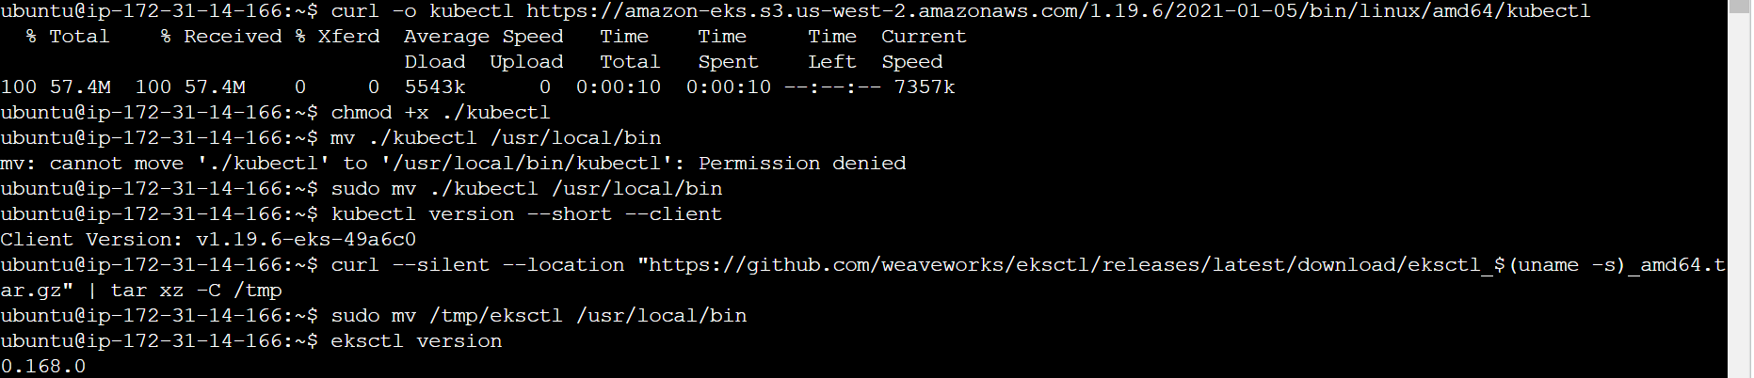

Installing awscli

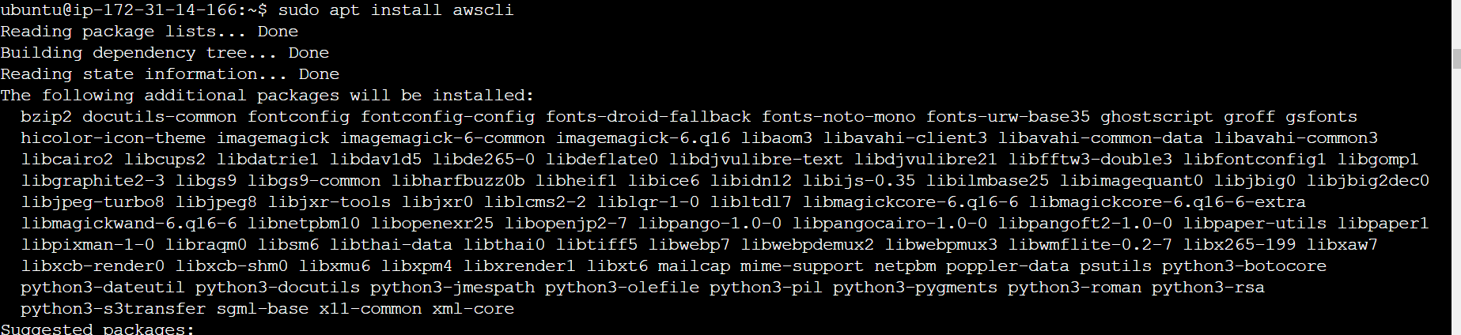

Configuring AWS

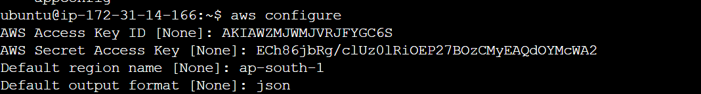

Creating Cluster

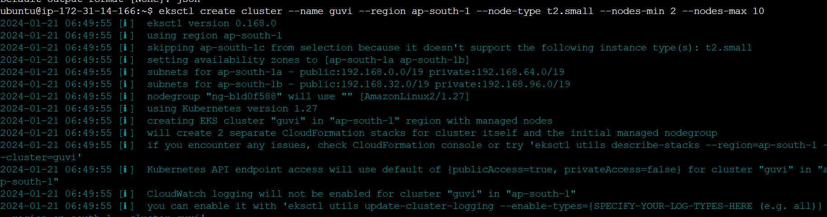

Cluster is created

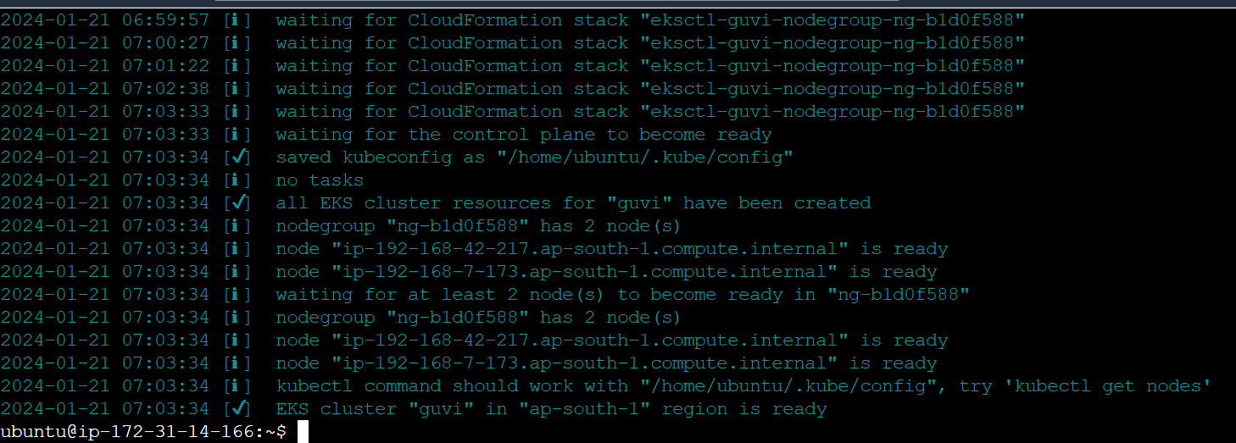

Deploying an nginix Application

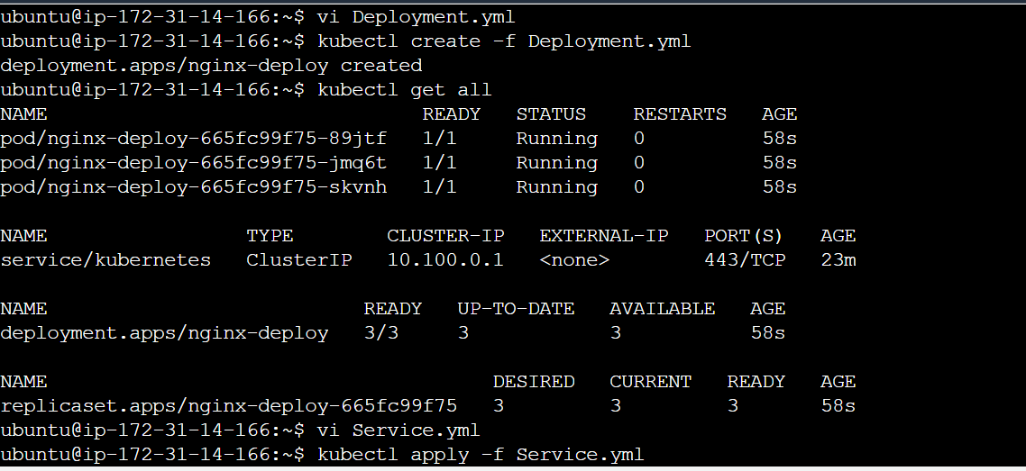

**Deployment.yml:**

**apiVersion: apps/v1**

**kind: Deployment**

**metadata:**

**name: nginx-deploy**

**labels:**

**app: nginx-app**

**spec:**

**replicas: 3**

**selector:**

**matchLabels:**

**app: nginx-app**

**template:**

**metadata:**

**labels:**

**app: nginx-app**

**spec:**

**containers:**

**- name: nginx-container**

**image: nginx:1.7.9**

**ports:**

**- containerPort: 80**

**Service.yml**

**apiVersion: v1**

**kind: Service**

**metadata:**

**name: my-Service**

**spec:**

**selector:**

**app: nginx-app**

**ports:**

**- protocol: TCP**

**port: 80**

**targerPort: 80**

**type: LoadBalancer**

Exposing it to internet

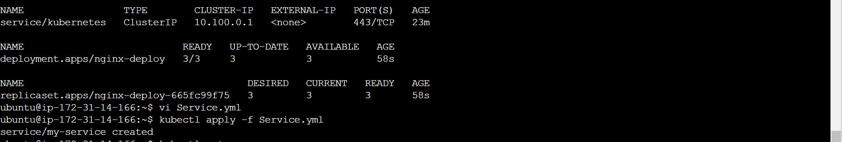

Output:

